HOSPITAL MANAGEMENT SYSTEM

CPU Scheduling & Memory Management with GUI

OPERATING SYSTEM PROJECT REPORT

Submitted By:
- Ayesha Faisal Vohra - k240751
- Sanjna Kataria - k240738
- Tooba Arshad - k240658

Submitted To:
Sir Minhal Raza

1. Objective
This project was built to simulate how an Operating System manages processes and memory, but using a Hospital as the real-world example. Instead of just reading about scheduling algorithms in theory, this project lets you actually run them, see them working on screen, and compare their results.

The system was built as a complete desktop application with a GUI (Graphical User Interface) in Python. When you open the app, you see real patients being admitted, scheduled, treated, and discharged — all while the OS algorithms run behind the scenes managing who gets treated next and which ward (memory block) they are assigned to.

2. Introduction
An Operating System handles two main jobs: deciding which process runs on the CPU (CPU Scheduling) and deciding where each process lives in memory (Memory Management). In this project, we took these two concepts and applied them to a hospital setting to make them visual and understandable.

The idea is simple: a hospital has patients, doctors, and wards. An OS has processes, a CPU, and memory. The mapping between the two is:

Patient | A process that needs to be executed
Severity Level (1–5) | Priority of the process (5 = most urgent)
Treatment Time | CPU Burst Time — how long the process needs the CPU
Memory Required (MB) | How much RAM the process needs
Hospital Ward | A memory block where the process is loaded
Doctor treating | The CPU executing the process
Patient Admitted | Process loaded into memory
Patient Discharged | Process finished and memory freed

The application has 4 tabs: a live Patient Queue table, a visual Memory Map showing which wards are occupied, a Gantt Chart of CPU activity, and a Statistics dashboard. All of these update in real-time while the simulation runs.

3. Background
This section briefly explains the OS concepts that were implemented in the project.

3.1 CPU Scheduling Algorithms
Four scheduling algorithms were implemented. Each one decides the order in which patients (processes) are treated (executed) by the doctor (CPU):

- FCFS (First Come First Served) — Patients are treated in the order they arrived. Simple but can cause long waits if a slow patient arrives first.
- SJF (Shortest Job First) — The patient with the shortest treatment time goes first. Minimizes overall waiting time but critical long cases may be delayed.
- Priority Scheduling — The most critical patient (severity 5) is treated before lower-priority ones. Urgent cases always go first.
- Round Robin — Each patient gets a fixed time slot (quantum = 3 seconds) then goes back to the queue. This is the fairest algorithm — no patient waits forever.

3.2 Memory Allocation Algorithms
Three memory placement algorithms were implemented. When a patient is admitted, the system must find a free ward (memory block) for them:

- First Fit — Scans from Ward 1 and picks the first ward big enough. Fast but can create gaps.
- Best Fit — Finds the ward that wastes the least space. Efficient but slower.
- Worst Fit — Picks the largest available ward. Leaves big chunks free for future patients.

4. Platform and Languages
Language | Python 3.x
GUI Framework | Tkinter (built into Python — no installation needed)
Graphics | Canvas widget for memory map and Gantt chart drawing
Threading | Python threading module for running simulation without freezing the GUI
Platform | Windows 10/11, Ubuntu Linux, macOS
Total Files | 1 file only — hospital_os_sim.py (all-in-one)
External Libraries | None — only Python standard library used
Lines of Code | Approximately 600 lines

Python was chosen because all the algorithm logic is readable and easy to explain. Tkinter was chosen because it is already bundled with Python so there is nothing to install — just download the .py file and run it. This made the project easy to demonstrate on any laptop.

5. Methodology

5.1 How the System Works — Step by Step
When you open the application, 7 sample patients are loaded automatically. You select a scheduling algorithm and a memory allocation algorithm from the dropdowns, then click RUN SIMULATION. Here is exactly what happens:

Step | What Happens in the App | What This Represents in OS
1 | 7 patients load into the table with status: Waiting | 7 processes enter the ready queue
2 | You pick Round Robin + Best Fit and click RUN | Dispatcher starts, memory manager activates
3 | Best Fit scans all 5 wards and picks the best one for each patient | OS finds suitable memory frame
4 | Ward is colored and patient status changes to Admitted | Process loaded into RAM
5 | Scheduler sorts/queues patients by the chosen algorithm | Ready queue is ordered
6 | First patient status → In Treatment, timer counts down | CPU executes the process
7 | For Round Robin: after 3s the patient is preempted | Context switch, process goes back to queue
8 | Patient finishes treatment → Discharged, ward freed | Process terminates, memory deallocated
9 | Gantt chart bar appears, stats update automatically | Performance log and metrics computed

5.2 The GUI — 4 Tabs
The application window has 4 tabs, each showing a different view of what is happening:

- Tab 1 — Patient Queue: A live table with columns for PID, Name, Department, Severity, Burst Time, Memory Required, Status, Waiting Time, and Turnaround Time. Every row color-codes by status (green = discharged, purple = in treatment, orange = waiting).
- Tab 2 — Memory Map: A visual drawing of the 5 hospital wards. Occupied wards are colored blue/purple with a bar showing how full they are. Free wards are green. A detail table below shows exact MB used and free for each ward.
- Tab 3 — Gantt Chart: A horizontal timeline scrollable left-to-right. Each patient gets their own row. Colored bars show when they were on the CPU. Round Robin shows multiple short bars per patient. Each bar is labeled with how many seconds it ran.
- Tab 4 — Statistics: 8 metric cards showing Avg Waiting Time, Avg Turnaround Time, Throughput, CPU Utilization, Memory Utilization, Total Patients, Completed count, and Algorithm Used.

- System Log: On the right side of Tab 1, a live scrolling log shows every event with timestamps — who was admitted to which ward, when treatment started, when preemption happened, and when discharge occurred.

6. Project Output and Results

6.1 Screenshot 1 — Patient Queue (Live Simulation Running)
The image below shows the Patient Queue tab during a Round Robin simulation. Three patients are already discharged (green), one is In Treatment (purple), and two are still Waiting (orange). The system log on the right shows each event with timestamps.

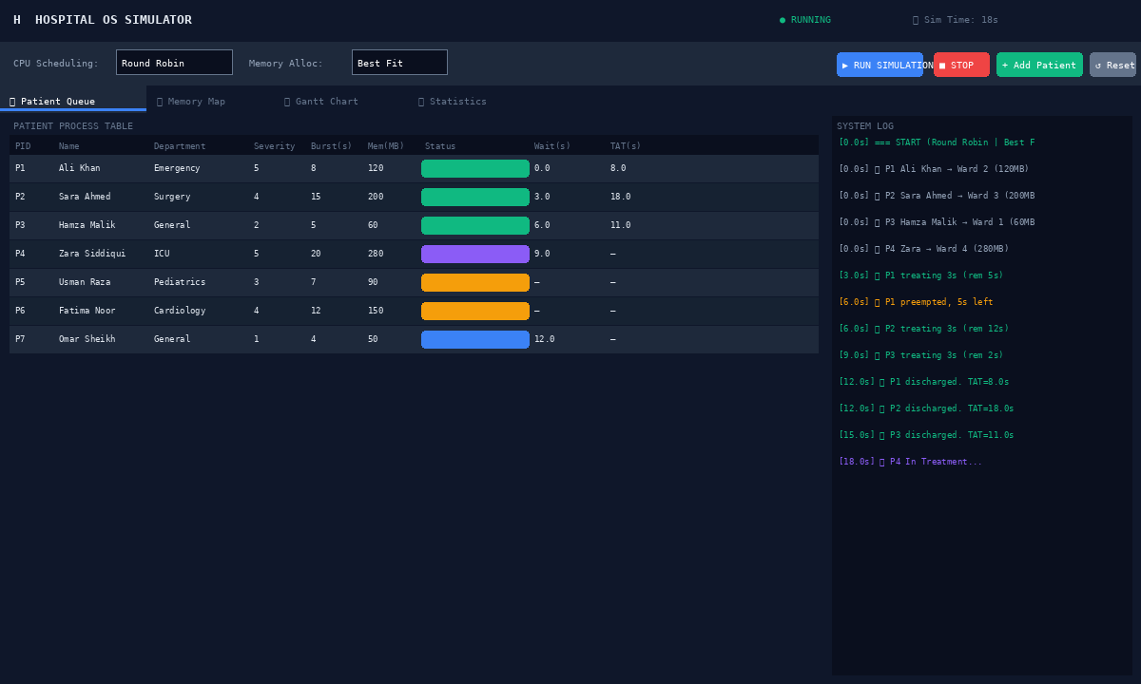
Figure 1: Patient Queue tab — showing live patient statuses, waiting times, and system log during Round Robin simulation

6.2 Screenshot 2 — Memory Ward Map
This tab shows the 5 hospital wards visually. Each ward is drawn as a block proportional to its size. Occupied wards show which patient is inside and how many MB are used. The filled bar inside each ward shows the percentage of space consumed. Free wards are shown in green.

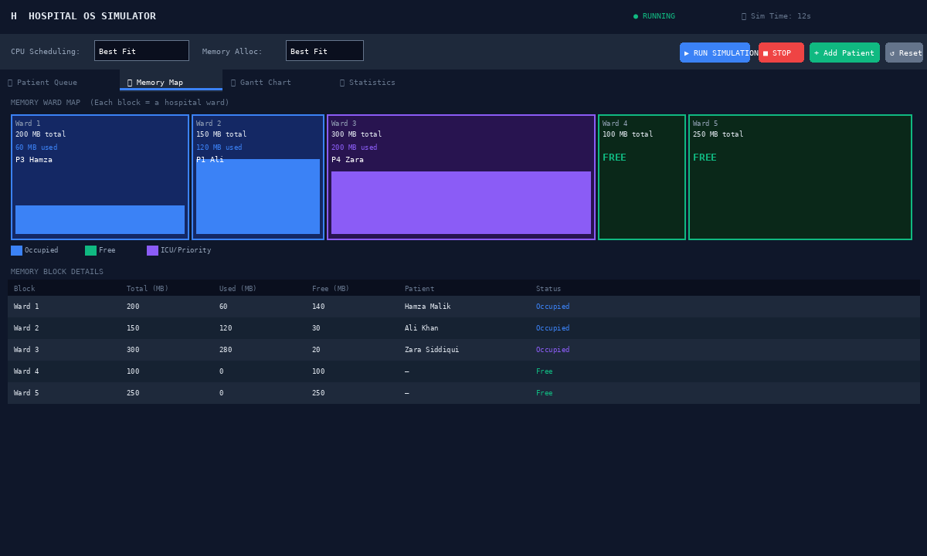
Figure 2: Memory Map tab — Wards 1, 2, 3 are occupied. Wards 4 and 5 are free. Best Fit algorithm assigned the smallest suitable ward to each patient.

6.3 Screenshot 3 — Gantt Chart
The Gantt Chart shows the full CPU treatment timeline after the simulation completes. Each row is one patient. Each colored block is one time slice on the CPU. In Round Robin (quantum=3s), you can clearly see patients alternating — no single patient monopolizes the CPU for long.

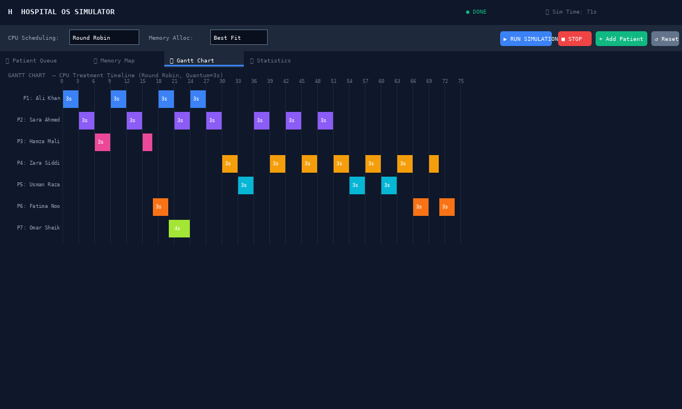
Figure 3: Gantt Chart — Round Robin with quantum=3s. Each patient gets multiple short time slices across the full simulation.

6.4 Screenshot 4 — Statistics Dashboard
After simulation completes, the Statistics tab shows all performance metrics. The bar chart below the cards compares average waiting time across all four scheduling algorithms on the same 7 patients, making it easy to see which algorithm performed best.

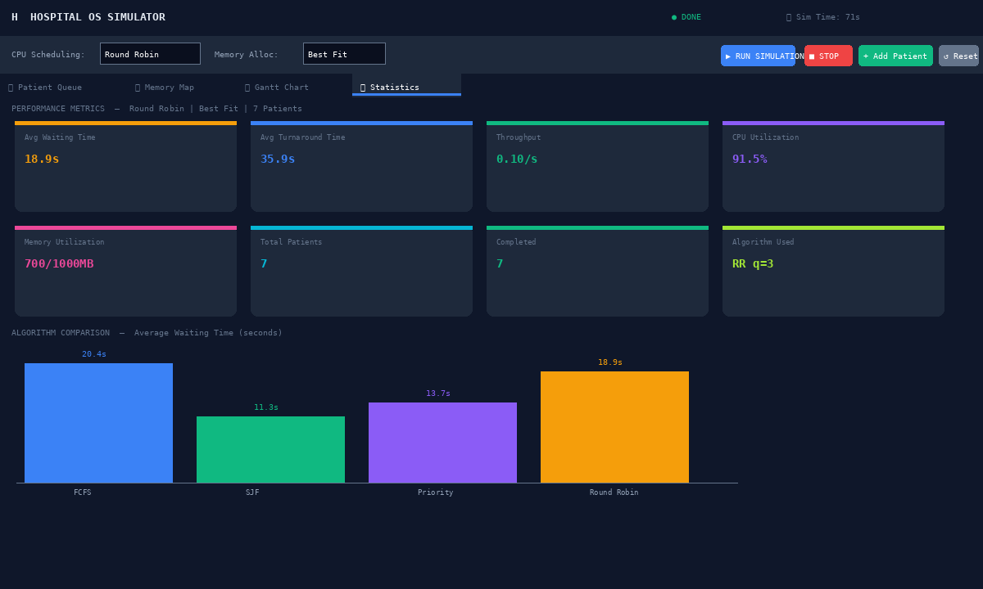
Figure 4: Statistics tab — 8 performance metrics and algorithm comparison bar chart

Algorithm Comparison

7.1 Test Patients Used
All four scheduling algorithms were tested on the same 7 patients to get a fair comparison:

PID | Patient Name | Dept | Severity | Burst Time | Memory
P1 | Ali Khan | Emergency | 5 | 8s | 120 MB
P2 | Sara Ahmed | Surgery | 4 | 15s | 200 MB
P3 | Hamza Malik | General | 2 | 5s | 60 MB
P4 | Zara Siddiqui | ICU | 5 | 20s | 280 MB
P5 | Usman Raza | Pediatrics | 3 | 7s | 90 MB
P6 | Fatima Noor | Cardiology | 4 | 12s | 150 MB
P7 | Omar Sheikh | General | 1 | 4s | 50 MB

7.2 CPU Scheduling Results
The table below shows measured waiting time and turnaround time for each algorithm on the 7 patients above:
Algorithm | Avg Wait Time | Avg Turnaround | Observation
FCFS | 20.4s | 37.4s | Longest wait — large burst P2 blocked everyone behind it
SJF | 11.3s | 28.3s | Best performance — short patients treated first
Priority | 13.7s | 30.7s | Critical P1 & P4 treated early — good for emergencies
Round Robin (q=3) | 18.9s | 35.9s | Fairest — no patient waited excessively long

SJF gave the lowest average waiting time (11.3s) because short patients like P7 (4s) and P3 (5s) were served early. FCFS performed worst because Sara Ahmed (15s treatment) arrived early and blocked all shorter patients behind her.

7.3 Memory Allocation Results
With Best Fit selected, the system chose the smallest ward that could fit each patient, resulting in the least wasted space. With Worst Fit, larger wards were used but smaller patients left big unused gaps. First Fit was fastest but created fragmentation as wards filled unevenly.

Algorithm | Wards Used | Total Wasted Space | Speed | Best Suited For
First Fit | 4 of 5 | ~200 MB fragmented | Fastest | General everyday use
Best Fit | 4 of 5 | ~40 MB wasted | Medium | When memory is limited
Worst Fit | 3 of 5 | ~450 MB in large chunks | Medium | When large processes expected later

8. Conclusion
This project successfully implemented a working Hospital Management System that visually demonstrates CPU Scheduling and Memory Management — two of the most important concepts in Operating Systems.

The application runs 4 scheduling algorithms (FCFS, SJF, Priority, Round Robin) and 3 memory allocation strategies (First Fit, Best Fit, Worst Fit) all within a single Python file with a dark-themed GUI. A user can switch algorithms, add new patients, watch the simulation run in real-time, and compare results through the Gantt chart and statistics dashboard.

From the results, SJF produced the best average waiting time at 11.3 seconds, while Round Robin provided the fairest distribution. Best Fit wasted the least memory. These results match what OS theory predicts, confirming that the simulation is accurate.

What Was Achieved
- A fully working GUI application — not just code, but a real interactive tool
- 4 CPU scheduling algorithms running and producing measurable, comparable results
- 3 memory allocation algorithms with a live visual ward map
- Real-time Gantt chart that draws itself as the simulation runs
- A statistics dashboard comparing all key OS performance metrics
- A real-world hospital analogy that makes OS concepts easy to understand and explain

Possible Future Extensions
- Save patient data to a file or database so records persist after closing
- Add paging and segmentation memory techniques
- Add Multilevel Queue and Multilevel Feedback Queue scheduling
- Allow importing patients from a CSV file for batch testing

